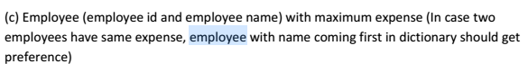

**Solution:-**

Created a reference named **‘a’** and referred the file named Employee_Expense.txt.



Loaded the file that is referred by **‘a’** using dump command.



Please find the output of **“dump a”** below.

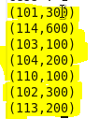

Created a reference named **‘b’** and referred the file named Employee_Detail.txt.



Loaded the file that is referred by **‘b’** using dump command.



Please find the output of **“dump b”** below

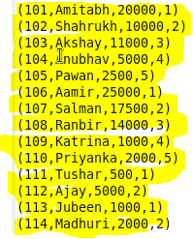

We have **joined** relation a and b with a by empid and b by id.

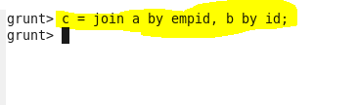

Loaded the file that is referred by **‘c’** using dump command.



Please find the output of **“dump c”** below

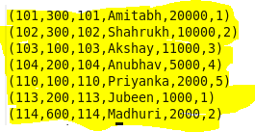

Below, we Ordered the file referred by **‘c’** with highest expenses and if expenses are same, then order the id’s in ascending so that we can get the employee names coming first in the dictionary.



Loaded the file that is referred by **‘d’** using dump command.



Please find the output of **“dump d”** below

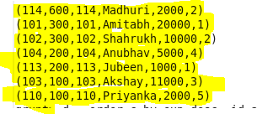

Now we need top3 employees with maximum expenses. So, We have selected **top 3 rows with the help of limit operator.**



Loaded the file that is referred by **‘e’** using dump command.

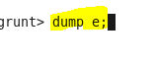

Please find the output of **“dump e”** below

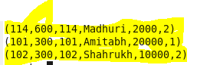

We need only empid and name in the result so we are generating empid and name for each row in relation e and is referred by relation res.



Loaded the file that is referred by **‘res’** using dump command.



Please find the output of **“dump res”** below

